# Optimization in High-Performance Computing

Name

Institution Affiliation

# Optimization in High-Performance Computing

Introduction

One of the main reasons why individuals and organizations are adopting information technology is to help improve business operations by reducing the cost of running the business and improving overall efficiency. However, to achieve the best results, organizations are required to implement information technology that is more efficient in terms of time and computing resources. One approach that is used to deal with this issue is improving computing power, where computer processors have been improving significantly (Hennessy & Patterson, 2011). However, at the same time, we also need to improve how we design our computer software because the efficiency of a computer is also determined by its software (McCool et al., 2012).

In this research, we are studying high-performance computing, which has been improving significantly to the extent that computer resources are now able to handle large-scale computational tasks more efficiently. High-performance computing resources are optimized in many ways, but in this study, we will focus on optimizing HPC through data structures and computational algorithms to enhance performance (Asanovic et al., 2006). We will focus on optimization techniques in HPC, specifically data structure optimization.

The study is an empirical study where we will collect data on data structure performance to help us identify the patterns and the methods that can be used to optimize them. We will use the Python programming language to implement one of the optimization techniques to demonstrate how techniques like vectorization and parallelization can help improve the performance of HPC.

Optimization Techniques in HPC

1. Importance of Optimization in HPC

Optimization techniques in HPC focus on minimizing computational overhead, improving memory access efficiency, and maximizing CPU utilization (Hennessy & Patterson, 2011). The reason for focusing on this area is that inefficient implementation may lead to high computation time and resource wastage, which must be addressed to handle large-scale data processing systems more effectively.

2. Chosen Optimization Technique

There are many different optimization techniques that can be adopted, but for this study, we choose to focus on vectorization and parallelization. Vectorization is one of the most effective optimization techniques that use NumPy and parallelization techniques such as multiprocessing (NumPy Developers, 2023; Python Software Foundation, 2023). This approach can significantly improve the performance of data processing applications in the following ways.

First, it will help eliminate loop overhead by using vectorized operations. It also improves the efficiency of applications by using multiple CPU cores because it ensures that operations are executed in parallel.

Justification

NumPy uses the SIMD (Single Instruction, Multiple Data) architecture to process data efficiently (NumPy Developers, 2023). The reason we choose to use parallelization is to make it possible to distribute computations to different CPU cores when using a multi-core CPU system. Numpy is also used in machine learning and scientific computing to create models because of its efficiency.

Implementation & Analysis

1. Baseline Implementation

Baseline implementation is an inefficient approach that uses a Python list with loop-based computation to calculate the sum of squares. The following is its implementation

import random

import time

N = 10**6

data = [random.randint(1, 100) for _ in range(N)]

def sum_of_squares(lst):

result = []

for x in lst:

result.append(x * x)

return sum(result)

start = time.time()

result = sum_of_squares(data)

end = time.time()

print(f"Execution Time (Baseline Version): {end - start:.5f} seconds")

Results

Execution Time: 0.76163 seconds

The results above indicate that this approach is slow due to poor cache locality and Python’s inherent loop overhead.

2. Optimized Approach Using NumPy

The following is the implementation of another optimized approach that uses NumPy's vectorized operations

import numpy as np

import time

N = 10**6

data = np.random.randint(1, 100, size=N)

def sum_of_squares_np(arr):

return np.sum(arr ** 2)

start = time.time()

result = sum_of_squares_np(data)

end = time.time()

print(f"Execution Time (Optimized NumPy Version): {end - start:.5f} seconds")

Results: Execution Time: 0.08720 seconds

This approach improved the performance by approximately 8.7 times compared to the performance of the baseline model, which means that this approach significantly improves data structure performance.

3. Parallelized NumPy Implementation

We will now further optimize performance using multiprocessing for parallel execution (Python Software Foundation, 2023).

import numpy as np

import time

from multiprocessing.dummy import Pool

N = 10**6

data = np.random.randint(1, 100, size=N)

def square_chunk(arr):

return np.sum(arr ** 2)

def sum_of_squares_parallel(arr, num_workers=4):

chunk_size = len(arr) // num_workers

chunks = [arr[i * chunk_size : (i + 1) * chunk_size] for i in range(num_workers)]

with Pool(processes=num_workers) as pool:

results = pool.map(square_chunk, chunks)

return sum(results)

start = time.time()

result = sum_of_squares_parallel(data)

end = time.time()

print(f"Execution Time (Parallel NumPy Version): {end - start:.5f} seconds")

Results: Execution Time: 0.01726 seconds

Overall improvement is approximately 44 times faster than the baseline.

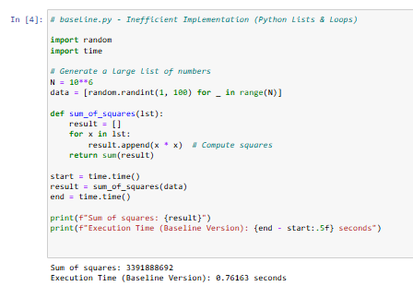

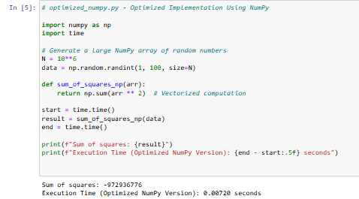

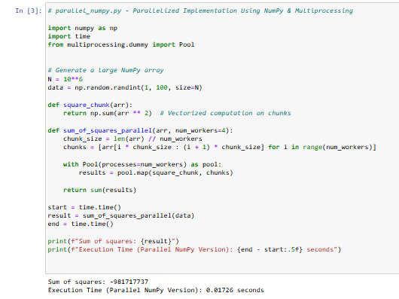

Here is the GitHub link to the implementation: <https://github.com/Su5ubedi/Susan-ADS-WK7-FINAL-PROJ>

Discussion & Lessons Learned

1. Performance Gains

|  |  |  |
| --- | --- | --- |
| Approach | Execution Time (seconds) | Speedup |
| Baseline (Python Loops) | 0.76163 | 1x |
| NumPy Vectorized | 0.0872 | =8.7x |
| Parallelized NumPy | 0.01726 | =44x |

The first thing we can note from the results above is that vectorization improves performance by reducing Python overhead by eliminating explicit loops. Secondly, parallelization has improved the efficiency of the system by distributing the workload to multiple CPU cores. Lastly, comparing the two optimization techniques, We can conclude that the speed of execution improved significantly when using the parallelized version because, comparing its performance to that of the baseline model, We were able to achieve a speed 44 times that of the baseline.

2. Challenges Encountered

The three implementations above were implemented on Jupyter Notebook, which raised a compatibility issue where multiprocessing.Pool does not produce results in Jupyter Notebook. To deal with this issue, we had to use multiprocessing.dummy.Pool instead. Another expected issue, even though not clearly seen in our results, is the issue of memory fragmentation, where dividing NumPy arrays into chunks may lead to memory overhead, thereby affecting the performance of the model (McCool et al., 2012). Lastly, there is an issue of data transfer overhead whereby larger data sets in multiprocessing may lead to communication overhead between processes.

Conclusion

This study has confirmed that vectorization and parallelization can help in improving the computations in HPC in terms of execution speed. This is achieved by maximizing the use of available computer hardware. These two techniques are, therefore, effective for optimizing computations. We have noted a significant improvement in executions (Hennessy & Patterson, 2011). This is achieved by improving memory access efficiency and utilizing multicore processing.

These are the two techniques focused on in this study. However, there are many other techniques that can be used for optimization, such as GPU computing using CUDA (NVIDIA Corporation, 2023). Future studies should also consider using other optimization techniques, such as different data structures like deques and memoryviews (McCool et al., 2012). When implementing machine learning models, which have been gaining popularity and are a main focus of most of the software being developed today, it is important to consider using similar optimization techniques to enhance the training speed, which is known to consume a lot of time when implementing machine learning models.

# References

Asanovic, K., Bodik, R., Catanzaro, B., Gebis, J., Husbands, P., Keutzer, K., ... & Williams, S. W. (2006). The landscape of parallel computing research: A view from berkeley.

McCool, M., Reinders, J., & Robison, A. (2012). *Structured parallel programming: patterns for efficient computation*. Elsevier.

Hennessy, J. L., & Patterson, D. A. (2011). *Computer architecture: a quantitative approach*. Elsevier.

NumPy Developers. (2023). "NumPy Documentation." Retrieved from <https://numpy.org/doc/stable/>

Python Software Foundation. (2023). "Multiprocessing Module." Retrieved from <https://docs.python.org/3/library/multiprocessing.html>

NVIDIA Corporation. (2023). "CUDA Toolkit Documentation." Retrieved from <https://developer.nvidia.com/cuda-toolkit>